PROBLEM SOLVING AND TESTING

NAME: T PRABHA SHREE

VTU NO: 30707

COURSE CODE :10211CS227

WEEK 2 PROBLEMS

2.1.Java Date and Time – https://www.hackerrank.com/challenges/java-date-and-time/problem
import java.io.*;
import java.math.*;
import java.security.*;
import java.text.*;
import java.util.*;
import java.util.concurrent.*;
import java.util.function.*;
import java.util.regex.*;
import java.util.stream.*;
import static java.util.stream.Collectors.joining;
import static java.util.stream.Collectors.toList;
class Result {

/*
* Complete the 'findDay' function belo
*
* The function is expected to return a STRING.
* The function accepts following parameters:
* 1. INTEGER month
* 2. INTEGER day
* 3. INTEGER year
*/

public static String findDay(int month, int day, int year) {
// Using java.time.LocalDate to easily find the day of the week
java.time.LocalDate dt = java.time.LocalDate.of(year, month, day);

// Returns the day of the week in capital letters (e.g., WEDNESDAY)
return dt.getDayOfWeek().toString();
}

}
public class Solution {
public static void main(String[] args) throws IOException {
BufferedReader bufferedReader = new BufferedReader(new InputStreamReader(System.in));
BufferedWriter bufferedWriter = new BufferedWriter(new FileWriter(System.getenv("OUTPUT_PATH")));

String[] firstMultipleInput = bufferedReader.readLine().replaceAll("\\s+$", "").split(" ");

int month = Integer.parseInt(firstMultipleInput[0]);

int day = Integer.parseInt(firstMultipleInput[1]);

int year = Integer.parseInt(firstMultipleInput[2]);

String res = Result.findDay(month, day, year);

bufferedWriter.write(res);
bufferedWriter.newLine();

bufferedReader.close();
bufferedWriter.close();
}
}
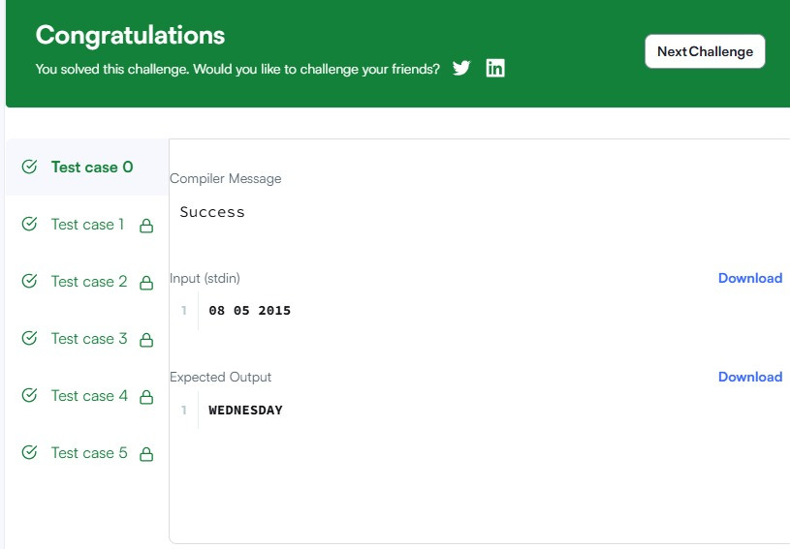
2.2. Number of Days Between Two Dates – https://leetcode.com/problems/number-of-days-between-two-dates/
import java.time.LocalDate;
import java.time.temporal.ChronoUnit;

class Solution {
public int daysBetweenDates(String date1, String date2) {
LocalDate d1 = LocalDate.parse(date1);
LocalDate d2 = LocalDate.parse(date2);

// Use ChronoUnit.DAYS.between to find the absolute difference in days
return (int) Math.abs(ChronoUnit.DAYS.between(d1, d2));
}
}
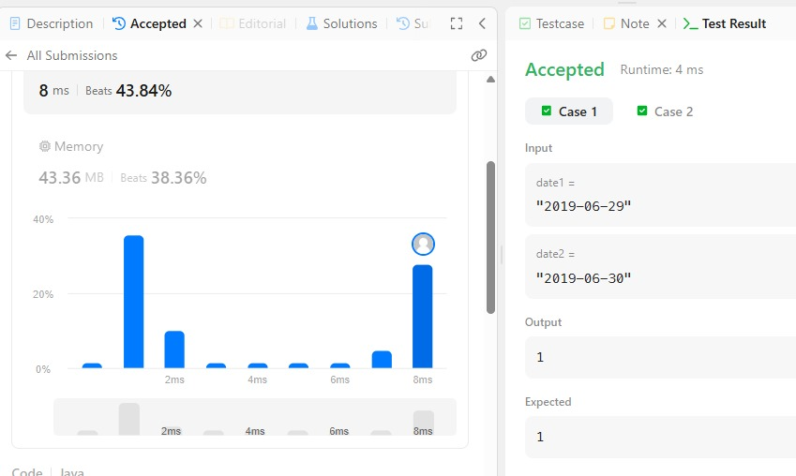
2.3.Day of the Year – https://leetcode.com/problems/day-of-the-year/
class Solution {
public int dayOfYear(String date) {
// Parse year, month, and day from the string
int year = Integer.parseInt(date.substring(0, 4));
int month = Integer.parseInt(date.substring(5, 7));
int day = Integer.parseInt(date.substring(8, 10));

// Days in each month for a non-leap year
int[] daysInMonths = { 31, 28, 31, 30, 31, 30, 31, 31, 30, 31, 30, 31 };

// Check for leap year and update February's days if necessary
if (isLeapYear(year)) {
daysInMonths[1] = 29;
}

// Sum up the days of the preceding months plus the current day
int dayOfYear = day;
for (int i = 0; i < month - 1; i++) {
dayOfYear += daysInMonths[i];
}

return dayOfYear;
}

private boolean isLeapYear(int year) {
// A year is a leap year if it is divisible by 4 and not 100,
// or if it is divisible by 400.
return (year % 4 == 0 && year % 100 != 0) || (year % 400 == 0);
}
}
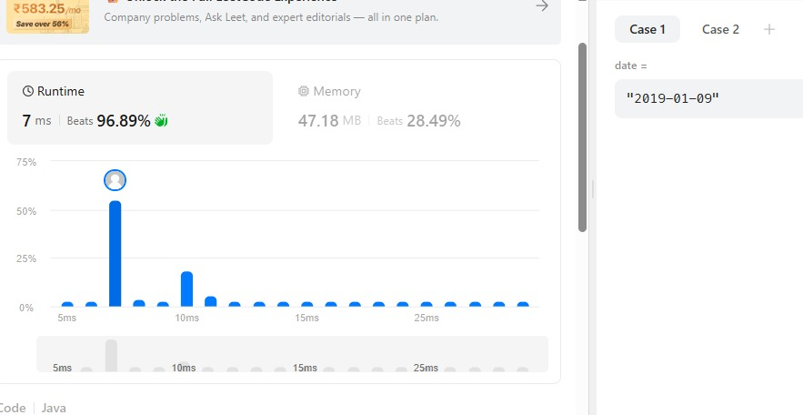

2.4.Day of the Week – https://leetcode.com/problems/day-of-the-week/
import java.time.LocalDate;
import java.time.format.TextStyle;
import java.util.Locale;

class Solution {
public String dayOfTheWeek(int day, int month, int year) {
LocalDate date = LocalDate.of(year, month, day);
return date.getDayOfWeek().getDisplayName(TextStyle.FULL, Locale.ENGLISH);
}
}
